Date:

Lab Session No.: 06

**Aim:**

Develop an android application that allows the user to rate an application.

**Software’s /IDE Tools:**

Android Development Kit / Android Studio

**Application User interface design:**

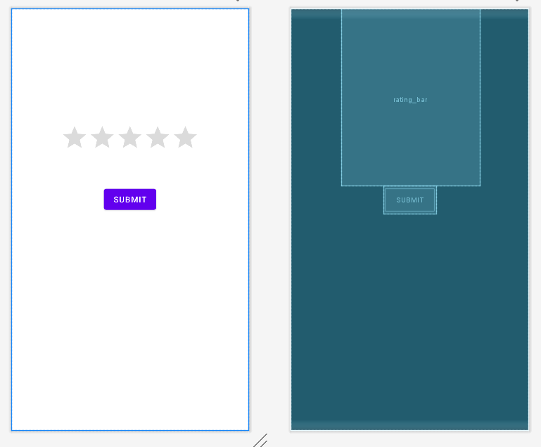

**Application Programming Interface:**

|  |  |  |  |
| --- | --- | --- | --- |
| **API / PACKAGES** | **CLASSES / INTERFACES** | **METHODS** | **DESCRIPTION** |
| import androidx.appcompat.app.AppCompatActivity; | AppCompatActivity | protected void onCreate(Bundle savedInstanceState) | onCreate(Bundle) is where you initialize your activity. When Activity is started and application is not loaded, then both onCreate() methods will be called. |
|  |  |
| import android.widget.EditText; | EditText | getText() | Determines the minimum type that getText() will return. If set, specifies that this TextView has a textual input method and should automatically capitalize what the user types. |

**Code/Implementation:**

// Develop an android application

// Project Name : ShareMyApp

/*

Lab Session No. : 06

Author : T.Avinash

Date :

Roll Number : 198W1A05C0

Description : Rating Bar

Softwares required :Android Studio

Topics Covered :

*/

***MainActivity.java***

package com.avinash.ratingbar;

import androidx.appcompat.app.AppCompatActivity;

import android.os.Bundle;

import android.view.View;

import android.widget.Button;

import android.widget.RatingBar;

import android.widget.Toast;

public class MainActivity extends AppCompatActivity {

RatingBar rating;

Button button;

@Override

protected void onCreate(Bundle savedInstanceState) {

super.onCreate(savedInstanceState);

setContentView(R.layout.activity_main);

rating=findViewById(R.id.rating_bar);

button=findViewById(R.id.btn1);

button.setOnClickListener(new View.OnClickListener() {

@Override

public void onClick(View v) {

String s=String.valueOf(rating.getRating());

Toast.makeText(getApplicationContext(),s+"stars", Toast.LENGTH_SHORT).show();

}

});

}

}

***activity_main.xml:***

<?xml version="1.0" encoding="utf-8"?>

<LinearLayout xmlns:android="http://schemas.android.com/apk/res/android"

xmlns:app="http://schemas.android.com/apk/res-auto"

xmlns:tools="http://schemas.android.com/tools"

android:layout_width="match_parent"

android:layout_height="match_parent"

android:orientation="vertical"

tools:context=".MainActivity">

<RatingBar

android:id="@+id/rating_bar"

android:layout_width="wrap_content"

android:layout_height="wrap_content"

android:numStars="5"

android:stepSize="0.5"

android:paddingTop="200dp"

android:paddingBottom="50dp"

android:layout_gravity="center"

app:layout_constraintBottom_toBottomOf="parent"

app:layout_constraintLeft_toLeftOf="parent"

app:layout_constraintRight_toRightOf="parent"

app:layout_constraintTop_toTopOf="parent" />

<Button

android:id="@+id/btn1"

android:layout_width="wrap_content"

android:layout_height="wrap_content"

android:layout_gravity="center"

android:text="submit" />

</LinearLayout>

**Output:**

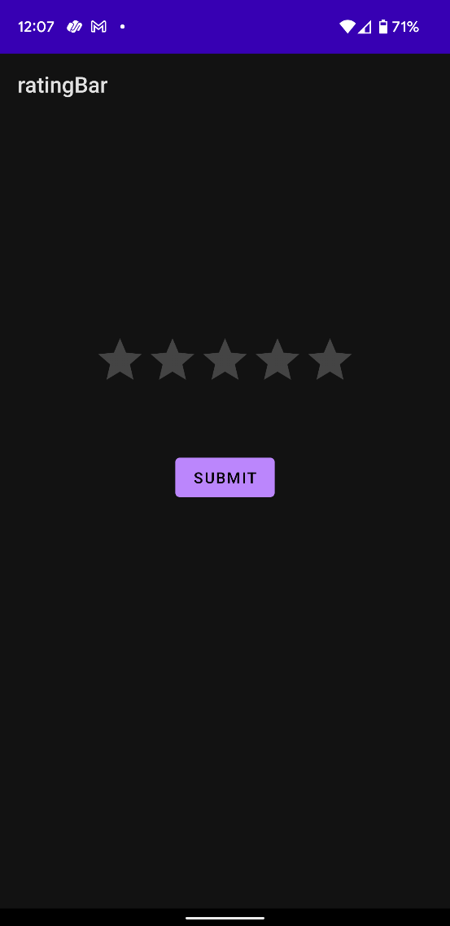 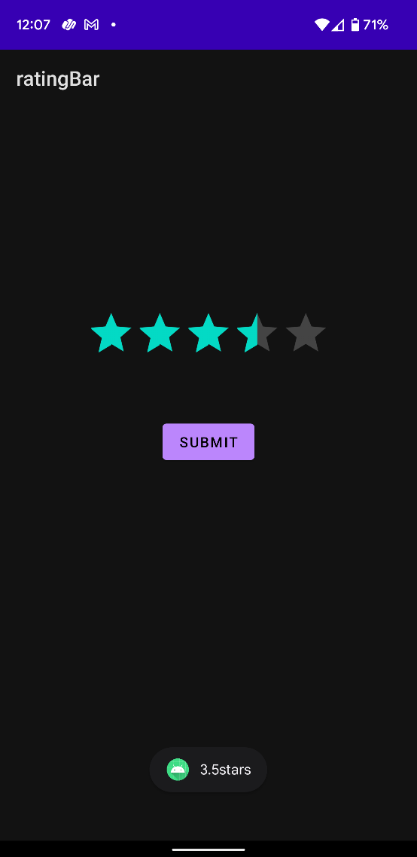

**Result:**

Demonstration of the Rating Bar is done successfully.